

**Version 1.0.0.1**

Contents

Author 1

Introduction 1

Demography 2

Idea to Software 2

EXPECTATION 2

Installation 2

First Run 5

Switching to another Lotto Game 10

Getting the latest Draw Dates 11

Setup Lotto Outlet first 13

Adding your bet 14

Modify existing bets 19

Managing Claims 21

Move the target draw date of your bet 21

Pick Generator 21

Win Generators 21

Download Result 22

# Author

* Ryan Seth Roldan
* pogi_ka_talaga_grabe@yahoo.com

# Introduction

* Lotto Data Manager has been brought to life to assist the user to manage his luck, money, and time in playing the Lotto.
* There are times you cannot pick anymore a number because of frustration. This software will let you choose a number of random number generators for a pick as your bet.
* You can monitor your average spending per game.
* You can see the latest draw result without searching on the internet.
* It can assist you to manually pick your next number by having highlighting the pattern of drawn numbers on your bet versus the drawn result.

# Demography

Unfortunately, this has been programed locked on Philippine Lotto Game only as I only know how to play the games within the country.

# Idea to Software

When you are into playing the lotto game, you will sometimes wonder if you choose the most appropriate number pick as your bet following your divine ritual number pattern astrology technique. Frustration will follow that none of your chosen number will be drawn.

In your simple analysis, you tend to find a pattern on how a number has been drawn comparing it to the previous result. By formulating your own pattern analysis and comparing it to the historical drawn result, you were always hitting the right number once, twice thrice.

This software will specifically show you the simple pattern of picking up a random number as your bet, and how frequent a certain number has been drawn compare to previous drawn results.

# EXPECTATION

* WHAT EVER THE RECOMMENDATION ON THIS SOFTWARE AND ITS GIMMICK TO ENTICE YOU TO PICK UP A GENERATED NUMBERS AS YOUR BET, THAT WILL STILL BE A RANDOM NUMBERS AT BEST.
* DON’T HOPE THAT THIS WILL BE YOUR GATEWAY TO RICHEST.
* AT THE END OF THE DAY, LOTTO GAME IS A FAIR GAME NUMBER!!!

# Installation

1. Download the latest release on GITHUB

<https://github.com/AngelsSoftwareOrg/LottoDataManager/releases/>

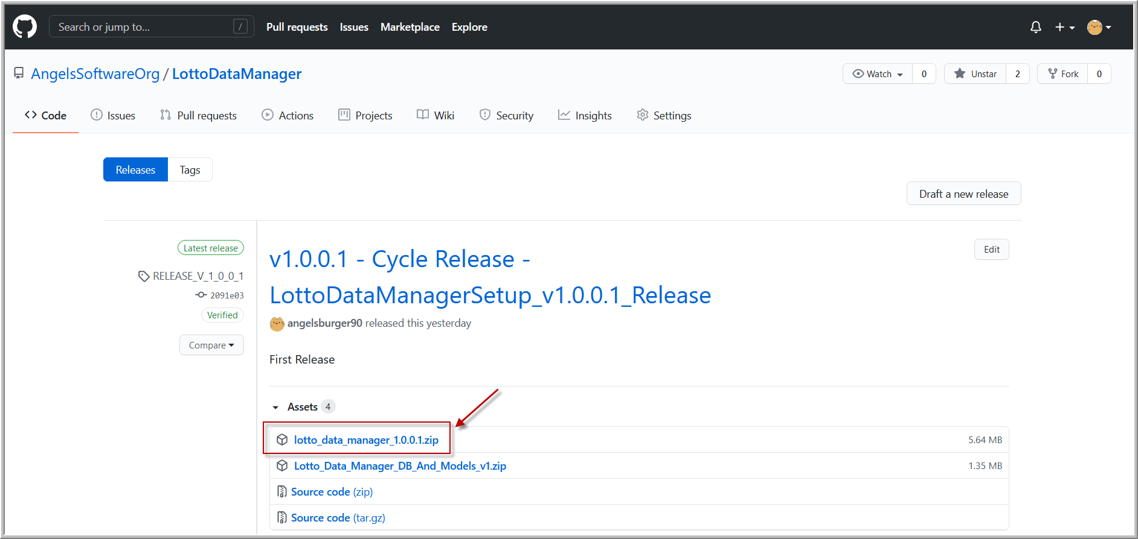

1. Extract the content of the zip file

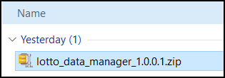

1. Double click to run the installer

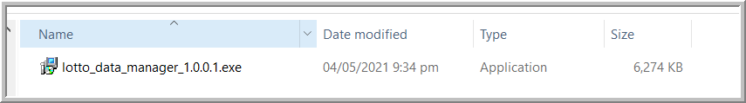

1. After installation, DON’T RUN IT YET

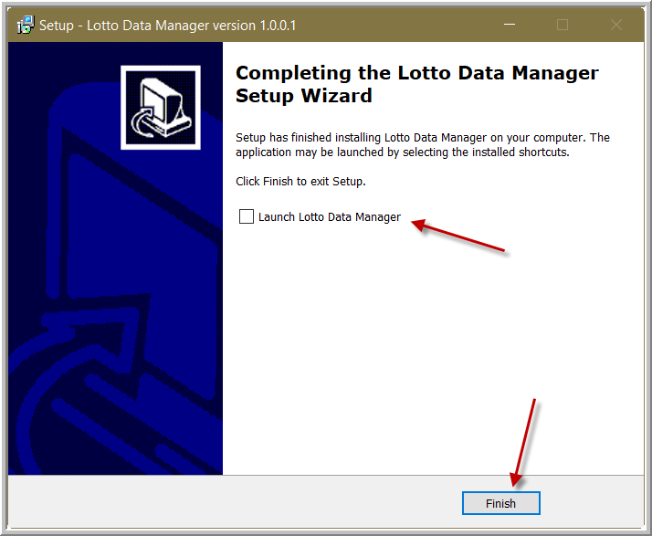

1. Download and install first the Microsoft Access Engine redistributable

<http://www.microsoft.com/en-us/download/confirmation.aspx?id=13255>

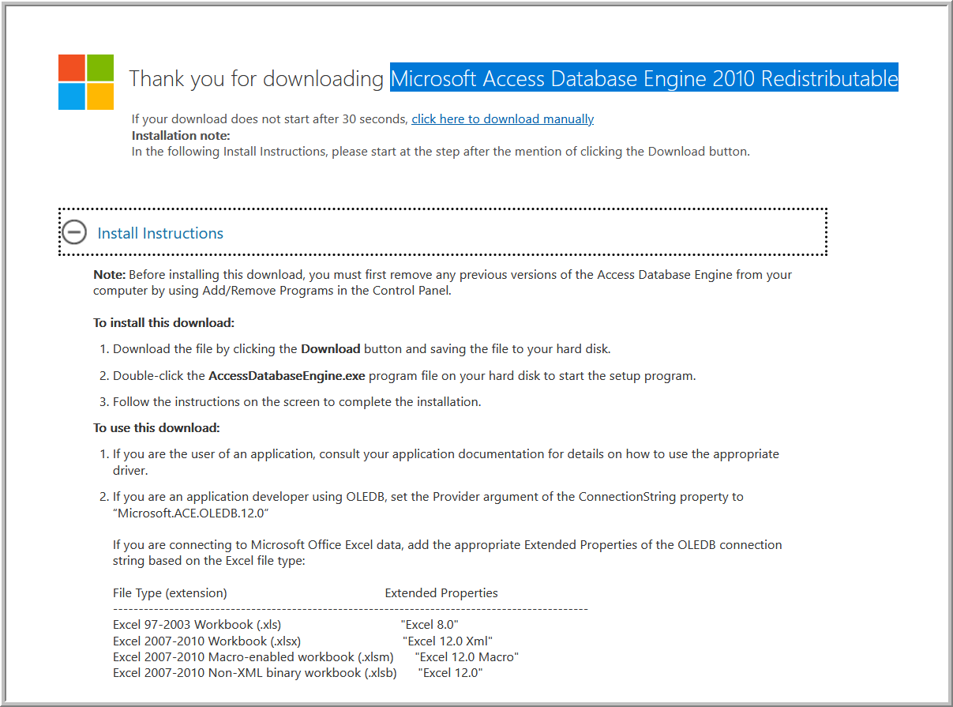

1. Then, try to running the program

# First Run

1. Run the program

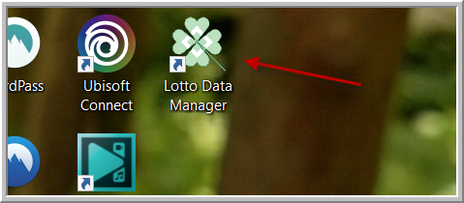

1. You will be prompt to point the database and machine learning models to use

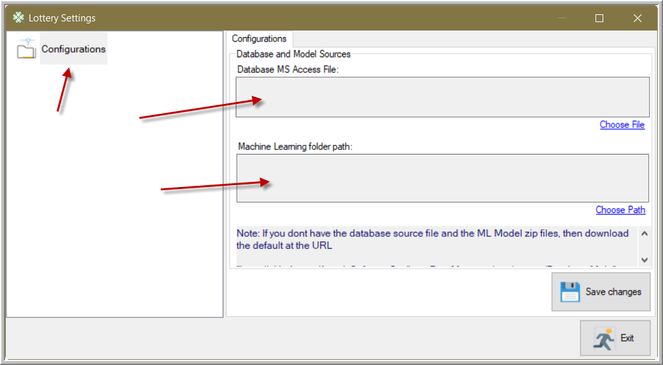

1. Back again on the latest release on GITHUB

<https://github.com/AngelsSoftwareOrg/LottoDataManager/releases/>

Download the Database and Models as highlighted below

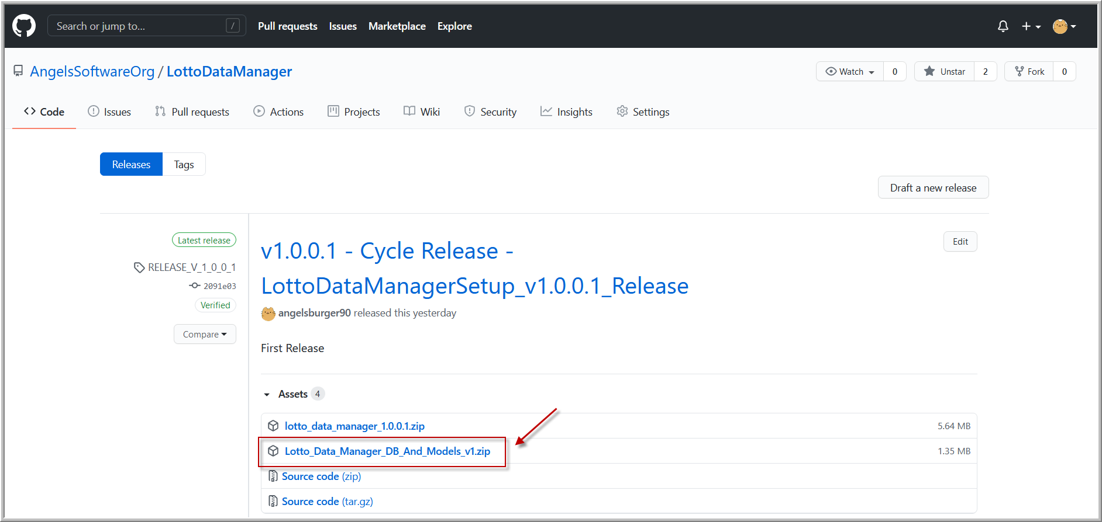

1. Extract the content of the zip file to your safe and comfortable location

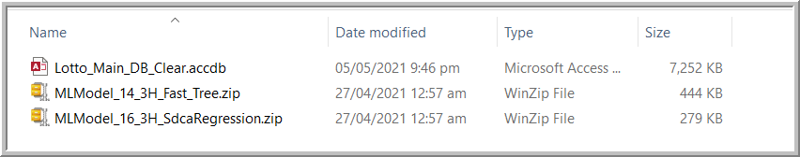

1. Going back to the main app, locate and place the Lotto Data Manager Database

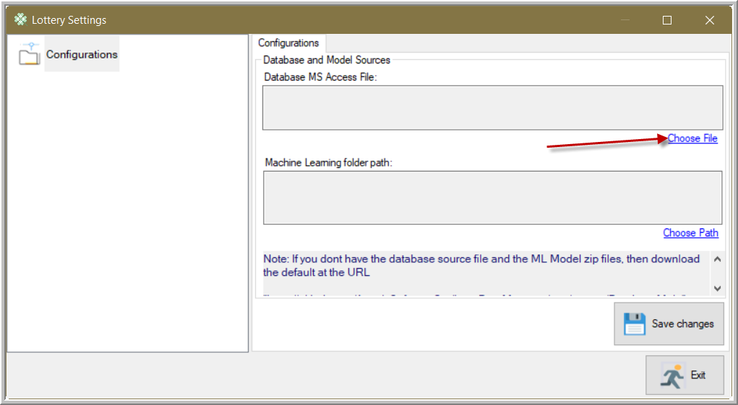

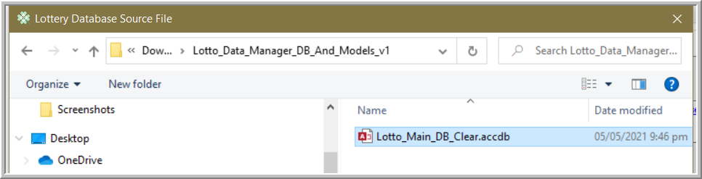

1. For the Machine Learning models, point the folder wherein the two zip files below are

These two are the Machine Learning models. Point the location wherein these two are.

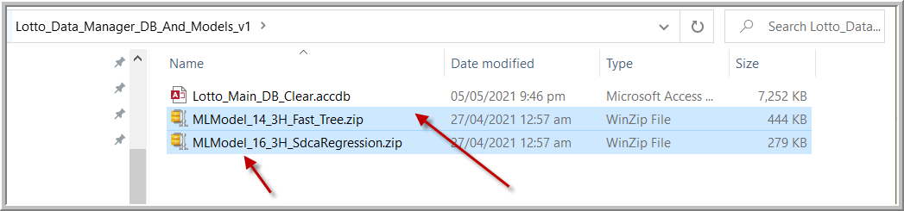

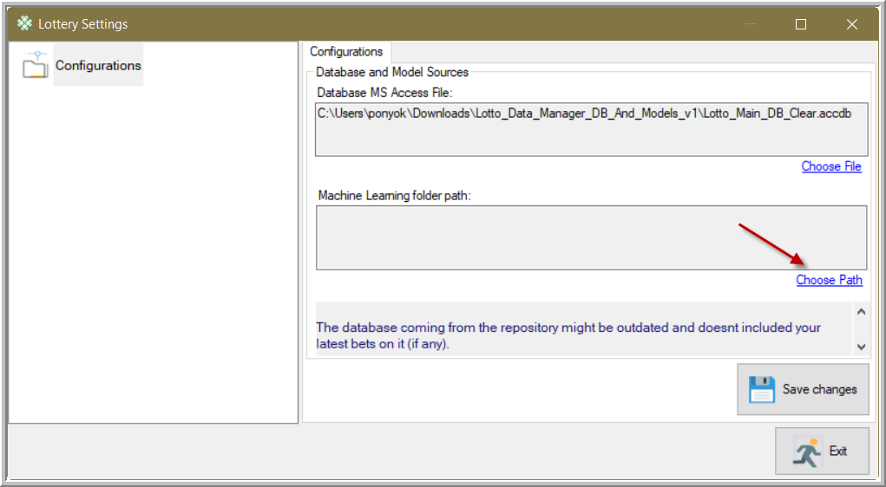

1. Then save your changes, and exit

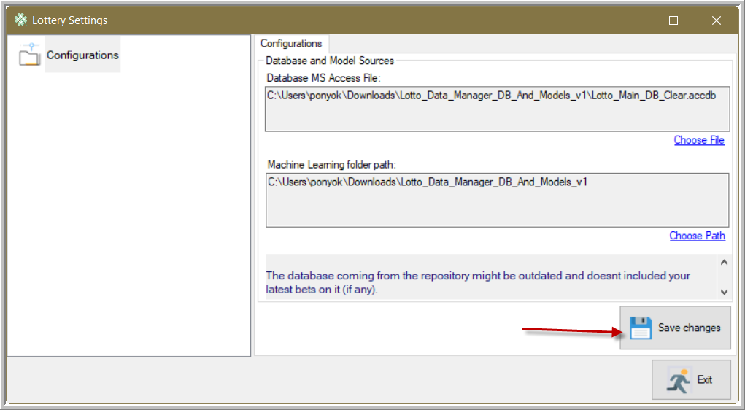

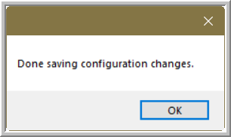

1. The main app will show up

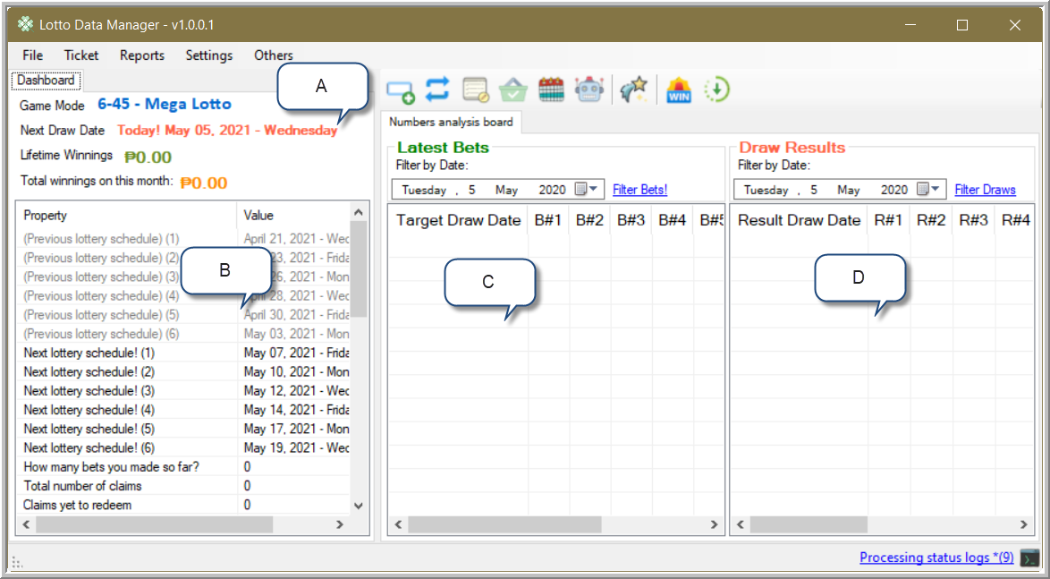

1. The current selected Lotto game you are managing
2. The quick dashboard to quickly see how you progress so far, and others information that might be helpful to you
3. The main board that displays your bets so far. It will display your bet record starting from one year ending today
4. The lotto draw result. It will display the resulting draw record starting from one year ending today

# Switching to another Lotto Game

Switching to another game is easy

By following the selection below, choose another game

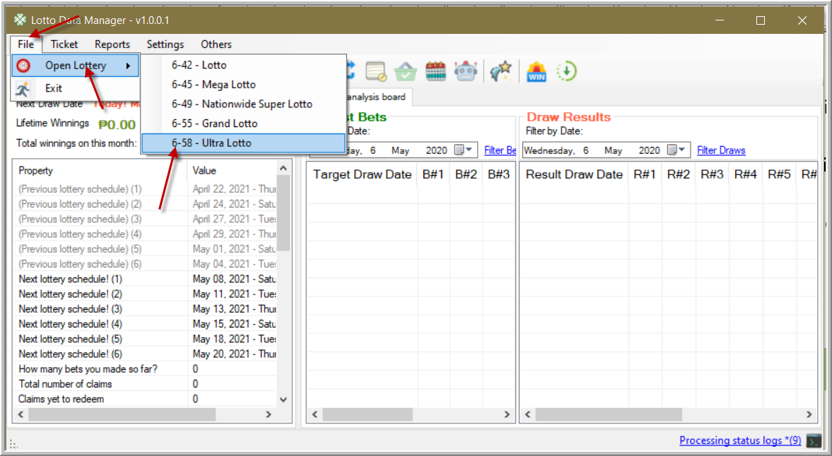

# Getting the latest Draw Dates

Getting the latest draw dates on the current selected Lotto game is easy

Click either of the two with the same Icon as shown below

1. From Others Menu -> Check Lottery Updates
2. From the standard tool bar

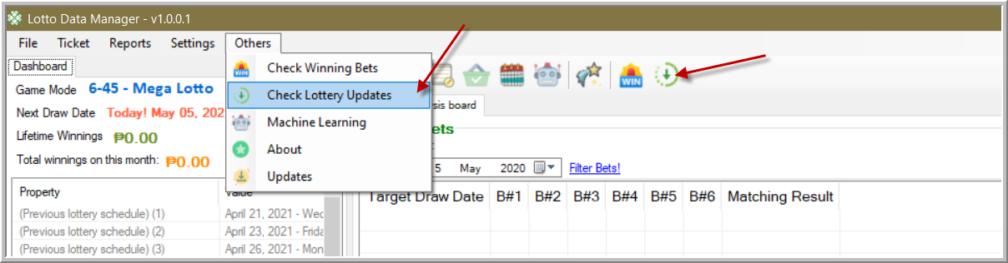

Upon clicking the update button, the app will start to scrape for the latest draw date.

To follow what’s happening on the background, click the status log on the bottom right for the latest activity

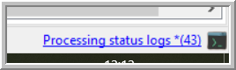

The logs will show you that it will only scrape result for the currently playing game which is 6-45

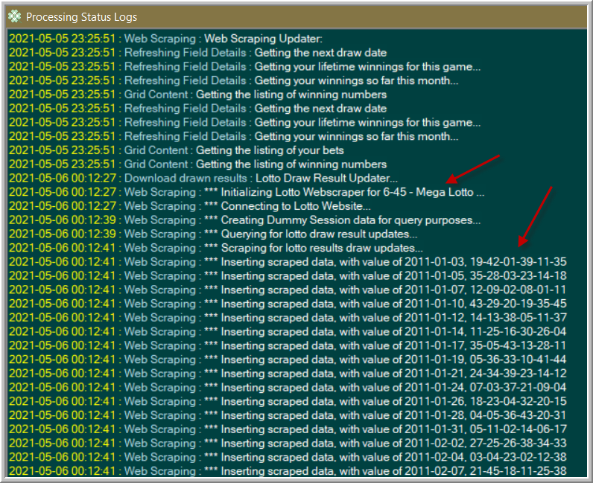

Exit the log status screen to go back to Main Form.

Here, it will display by the default the last one year drawn result data.

You may want to expand or narrow the listed results.

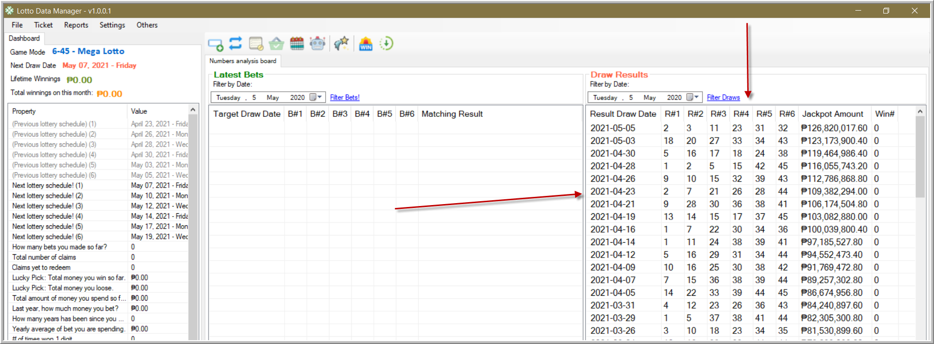

# Setup Lotto Outlet first

Setup your Lotto Outlet first because to ensure it will correctly place a right statistic which outlet generates most of your luck, by recording your bet and matching on the drawn results.

* Click Lottery Settings

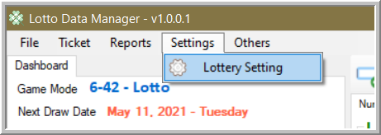

* Click the Lottery Outlet menu node on the left

The default outlet was “others” to record any outlet you forgot the place is

In the empty text box, you can put your new outlet there and hit save.

You can also modify the existing outlet by clicking one of the descriptions on the list, modify the description on the textbox and hit “Save modified outlet description”

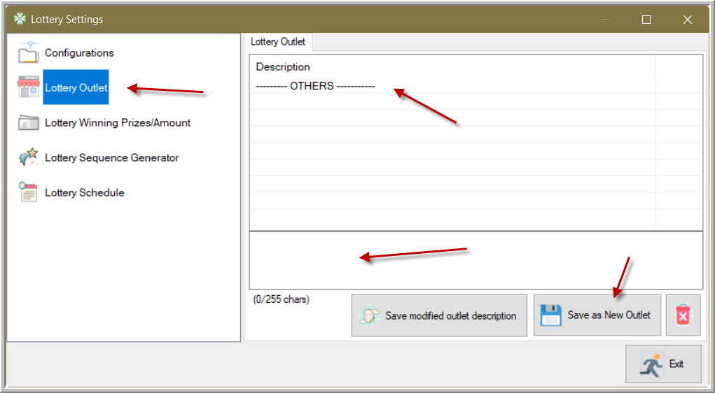

* After adding new lotto outlet

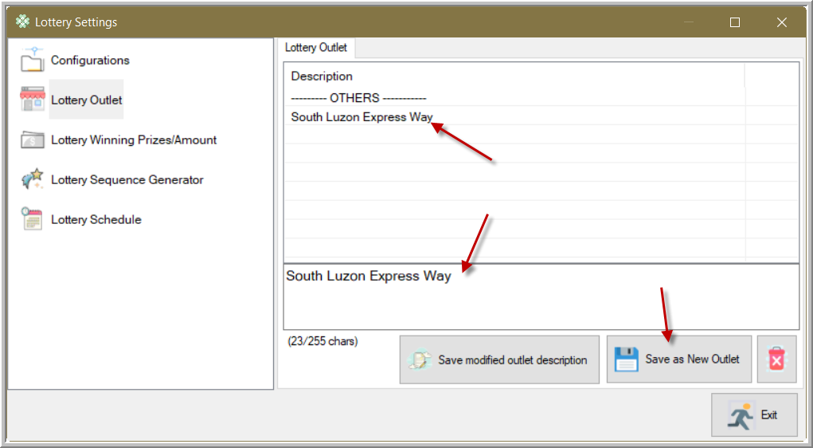

# Adding your bet

There are two ways to add your bet

1. Multiple bets
2. By input card layout

* Multiple Bets

Adding multiple bets is easy

1. Click either of the following, either by the menu or by the shortcut bar

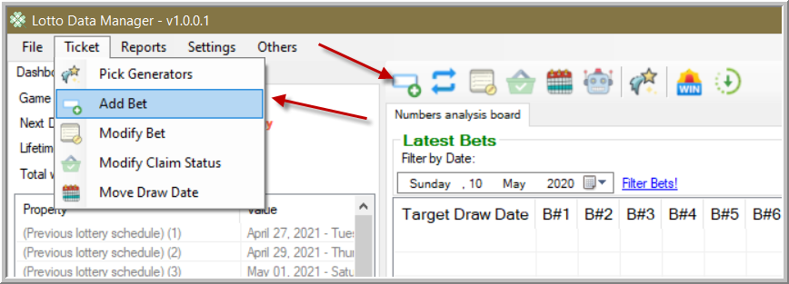

1. Click the first tab to input multiple bets at once

Place your bets separating numbers in allowed separator character

For now, choose the Next Draw Date to set your bet to

Pick you lotto outlet where you buy your Lotto Ticket

For this one, I choose this number randomly, so it’s my “Personal Pick” as my Pick Type

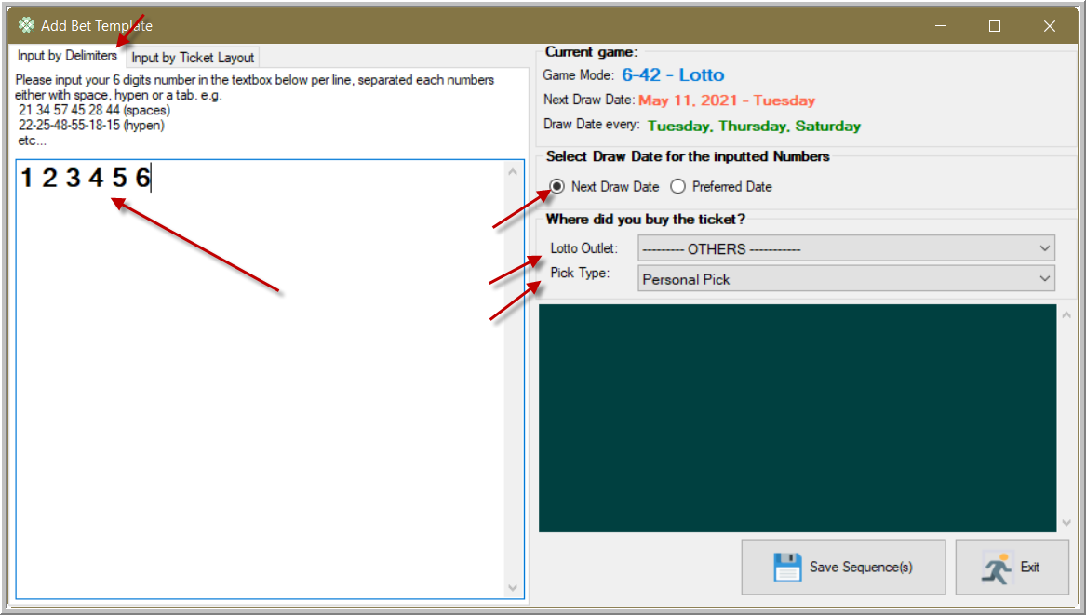

1. Clicking save will prompt you to double check your inputs. Hit ok if you’re satisfied

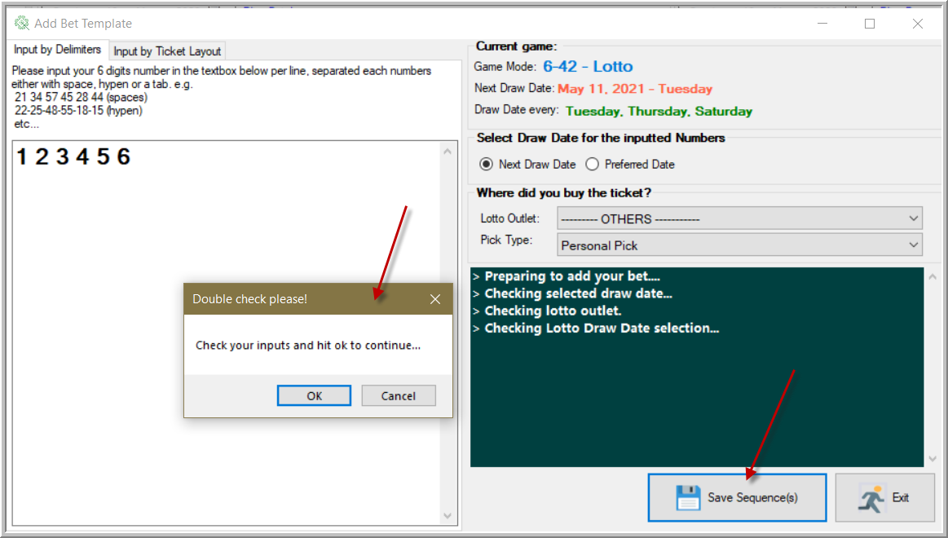

1. Saving your bets successfully

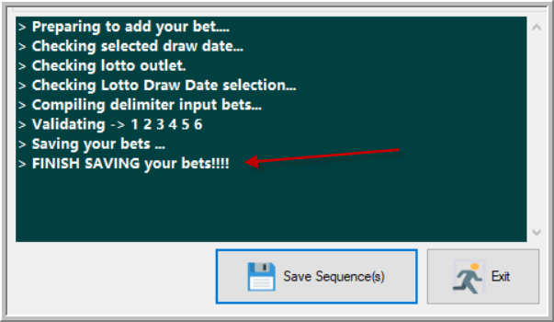

1. Return to Main Form, and the latest bets will display over there.

Your bet has been scheduled on May 11, but the latest result draw date is on May 8.

To update the draw result, click the Update button to let it save the latest draw date result.

It will automatically matchup the matching number from your bet from the drawn result.

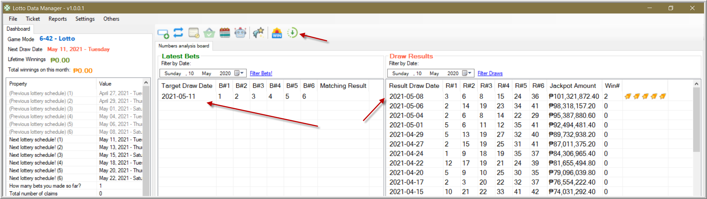

* Input card layout

1. When adding a new bet, click the 2nd tab

The numbered buttons below are layout like what on the actual ticket paper.

Select your numbers as your bet.

This time, we can only place one bet.

For the draw date, we put a previous draw date. In this case, the bet we put is a historical bet.

Save your bet and exit

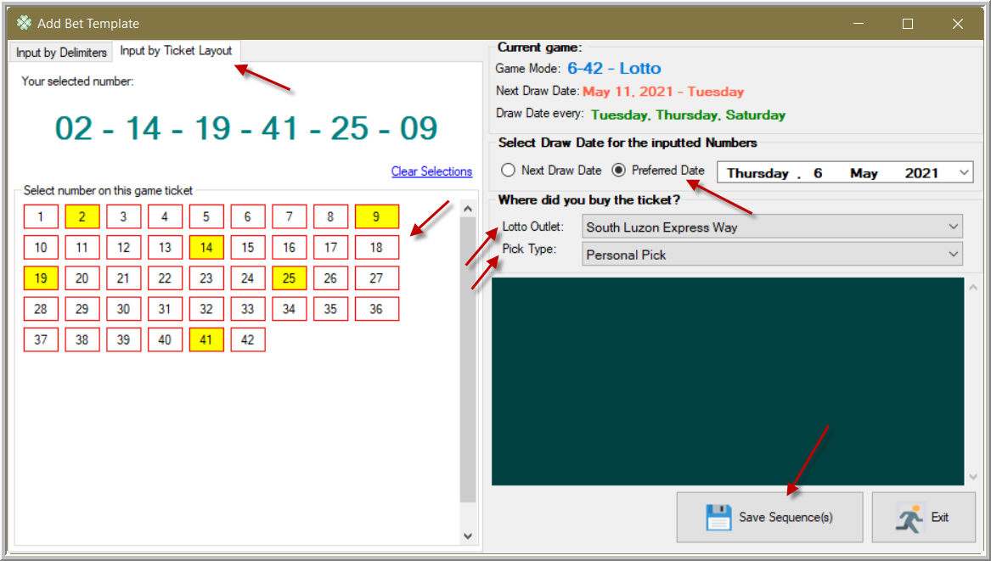

1. Upon exiting on the Add Bet Form, your numbers have been placed on the bet list and automatically matched to draw results making it mark that there’s a 4 matching numbers.

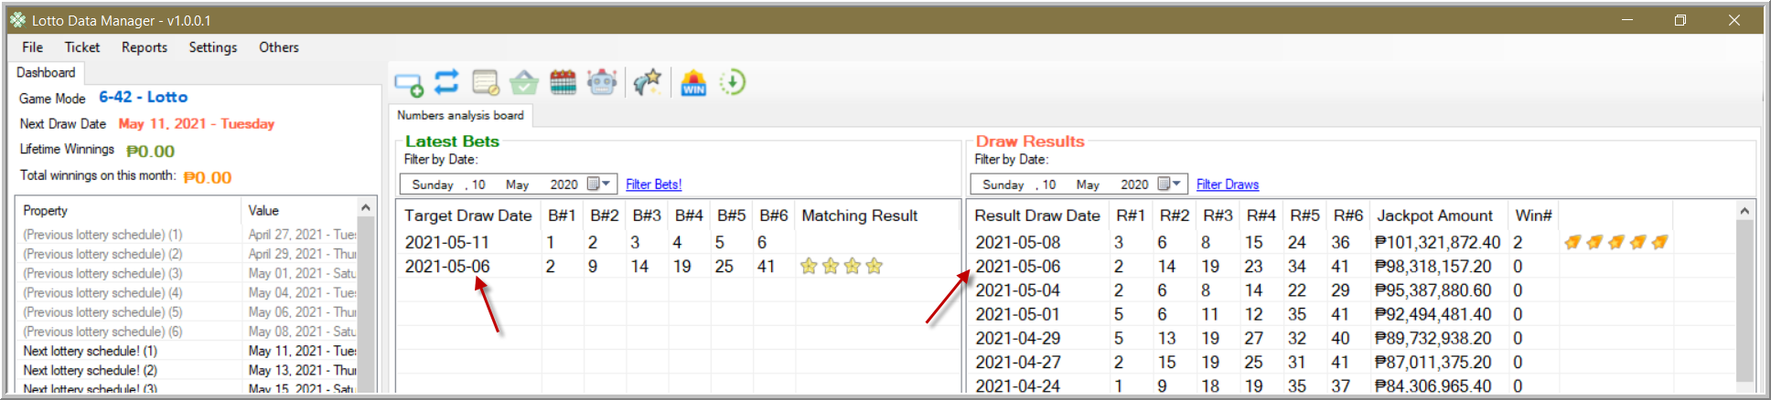

# Modify existing bets

To modify existing bet, click either of the following 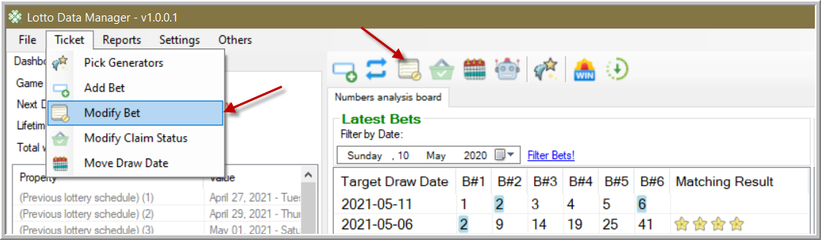

Or select a bet on the list, right mouse click and select the menu as shown below

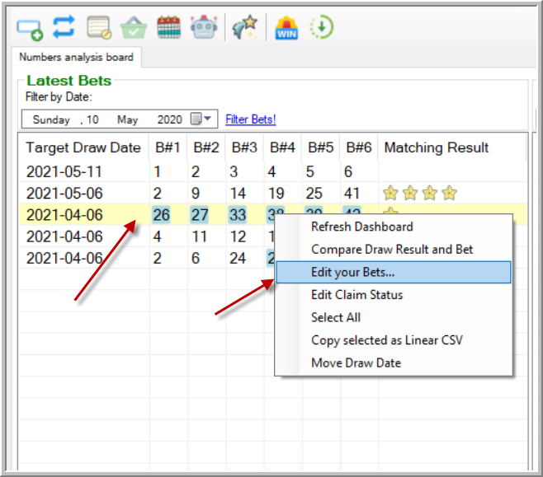

You can only modify the following

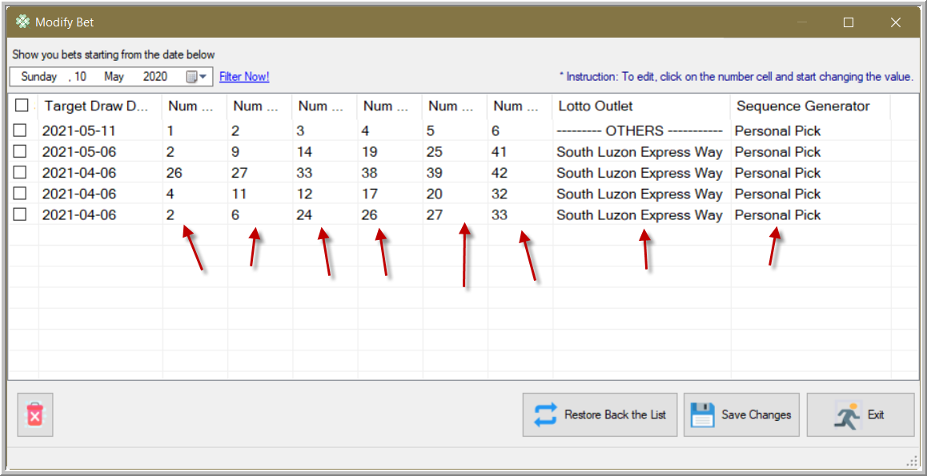

A modified entry will be Red highlighted. If you are satisfied with the change, then click Save button

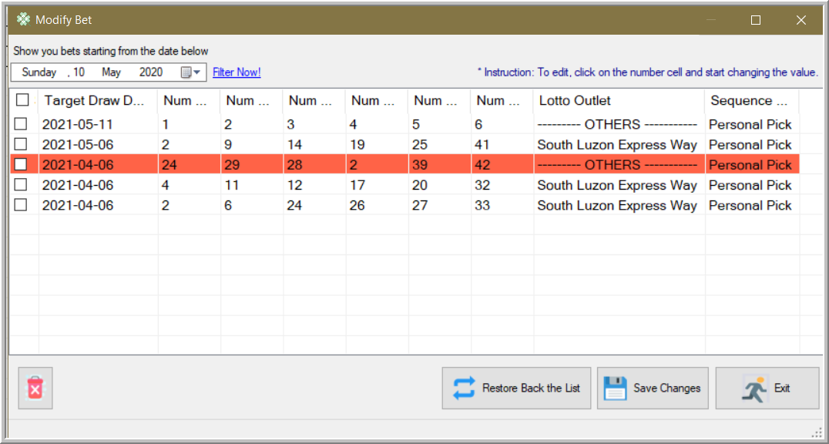

Your changes have been shown on the list

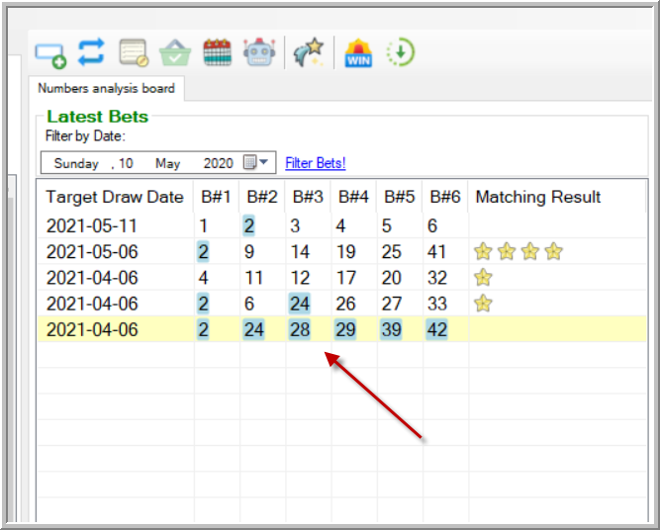

# Managing Claims

# Move the target draw date of your bet

# Pick Generator

# Win Generators

# Download Result